Starting with an equilateral triangle whose sides measure 27 units in length, we can determine initial area by inspection, or alternatively, can assert the overall area to be determined using properties of square numbers. At each layer of the triangle, the actual area of a given “sub-triangle”, or triangle inside the main triangle can be mapped to the layer number squared.

I.E. The area up to layer 1 of the triangle is 12 = 1

The area up to layer 4 of the triangle is 42 = 16

With that mapping clarified, we can assume that given a triangle of **side length L**, the area of any given triangle with be the number of layers it has, squared, I.E **L2**.

Our initial area, based on the previously stated premise, is then **272**. Starting with our initial triangle, each stage of Koch’s snowflake is formed by appending an additional triangle to each available side, all of which have an **L** equal to ⅓ of the base triangle.

I.E. For a triangle like our starter, with 3 side lengths of size 27, we place 1 new triangle

on each side with an L of (27/3) = 9

Given this definition, we know at **Stage 0**, we are required to append 3 new triangles on each of the 3 sides of our base triangle. Each time we add a new triangle, we stick it in the middle of the side, and remove the line where the base triangle and the added triangle meet.

I.E When we apply a triangle to a single side, we break the side into 3 separate segments.

We place one side of the triangle on top of the middle of the 3 segments. We then get rid

the line that makes up the base of our triangle, as well as the middle line segment, which

are the same thing. We have gone from 1 side to (1 triangle * 3 sides) + 3 segments - 2

overlapping segments. That is 1 side to 4 sides, for every single side currently available

Given the knowledge of the area of a given triangle, and the number of new sides we generate per go, we can establish a formula. For every given side of Koch’s snowflake, we know based on what we have said, that we need to add an additional triangle per side at each stage. We start dividing each of the 3 starting sides of our **L = 27** triangle into 4 new sides a piece, appending an additional triangle worth of area onto each of them. The exponential nature of the 4 side generation, leads to 4 new triangles per side every step except for the very first at stage 1.

At stage **zero**, we have our single triangle with an area of **272**.

At stage **one**, we have our original triangle with an area of 272, and 3 additional triangles, each with an area of 92, so our new area is 272 + 3(92).

At stage **three**, we have we have our original triangle with an area of 272, and 3 additional triangles, each with an area of 92, as well as 4 triangles generated for every side created from the previous stage’s triangles, or 3 * 4 triangles. Our new area is 272 + 3(92) + 3(4)(32)

Skipping the same process,

at stage **four**, Our new area is 272 + 3(92) + 3(4)(32) + 3(42)(12**)**

And so the summation trend continues.

In case it is unclear, our initial 3 sides generate 3 triangles, each of which produce 4 sides that generate 4 additional triangles per stage. This process continues with with the general summation trend of 3 * 4(n - 1) triangles per stage where n is the number of stages. As for area at each given point, this can be surmised from the nature of each triangle generated possessing a third of the side lengths of the triangle before it.

At **stage 0**, **L** is 27.

At **stage 1, L** is 9.

At **stage 2, L** is 3.

More generally, **L** can be expressed as the relation (27/3n), and area (**L2)** as (27/3n)2

What does all this mean? If we know the number of added triangles per stage [ 3 * 4(n - 1) ] as well as the area of each triangle per stage [ (27/3n)2 ], the overall area of Koch’s snowflake at any given point must be equal to the number of triangles * area of those triangles, from stage 1 to the desired stage. We exclude the very first level, and simply add on the 272 because it generates a number of triangles different from the rest (3 instead of 4).

Our formula: *Generated with Symbolab’s formula formatter, not used to solve

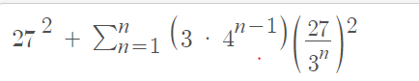

With the assistance of some algebra, and the shortcut provided by Prof. Krumpe for solving Infinite Geometric Series, the following exact area was derived.

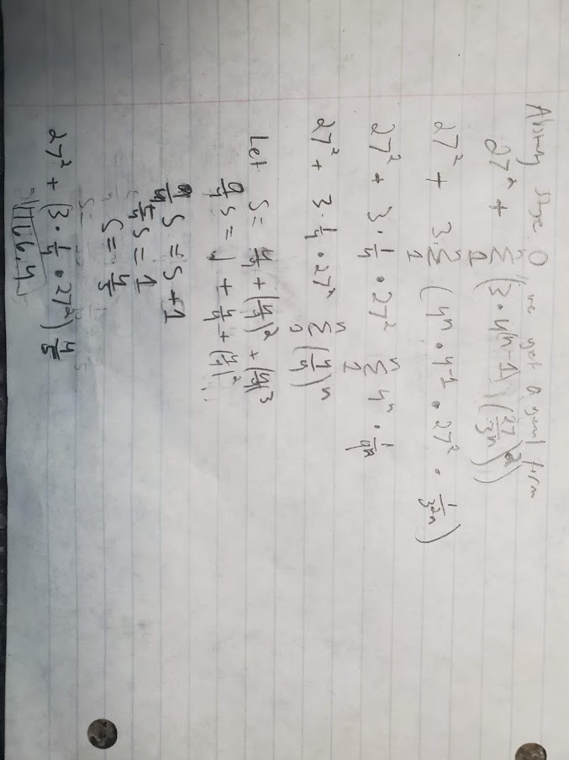

**1166.4 is our final answer**